Simple Average
Simple average is highly affected by outliers. For example if we have temperature values 10, 12, 13, 14, 16, 52 so their average comes out to be 21.4 which shows that temperature was around 22 but hold on it wasn’t the case!

Exponentially Weighted Moving Average (EWMA)
Exponentially weighted moving average solves this problem by incorporating history of the underlying trend. It doesn’t include effect of a new value 100% but it keeps track of base trend and adds some effect of new value.
EWMA = β (previous average) + (1 – β) (new value)
Now let’s come to our example.
t = 0 v = 12
t = 1 v = 12.1
t = 2 v = 12.29
t = 3 v = 12.661
t = 4 v = 16.59
So here we can see it’s really damping the impact of FIFTY-TWO (52).

EWMA has effect of roughly $\frac{1}{(1 - β)}$ observations !
It’s a famous statement that says EWMA has effect of roughly 1/(1- β) but let’s decode it.
We know that in simple average, each value has weight 1/n.
We also know that in EWMA, current observation has weight (1- β). So if we assume that current observation has weight 1/total_observations (concept from simple average), that means:
1/ total_observations = (1- β) => total_observations = 1/ (1- β)
That’s why we say that EWMA has effect of roughly 1/(1- β) observations.

EWMA in Stochastic Gradient Descent
As in stochastic GD loss fluctuates highly. So we use EWMA of gradients instead of heavily relying of newest gradient.
Further explanation in Notes.

Bias Correction
In previous example of temperatures, I took initial temperature as initial value.
But in ML algorithms we have to decide what to choose as initial velocity.

V⁰ = 0 ?
If we choose initial velocity zero, then EWMA would be slower to reach getting impact of even first value.
In our example of temperatures: 10, 12, 13, 14, 16, 52
t = 0 v = 0
t = 1 v = 1.2
t = 2 v = 2.38
t = 3 v = 3.542
t = 4 v = 4.787
t = 5 v = 9.508
Here we can clearly see that learning would be too slow.

V⁰ = theta_value ?
In that case, values would be biased towards value of initial theta. As we saw in very first example where effect of initial value (12) remained till t = 4.
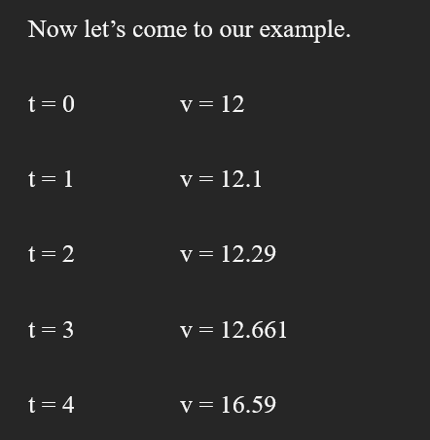
Therefore, following reasons hold:
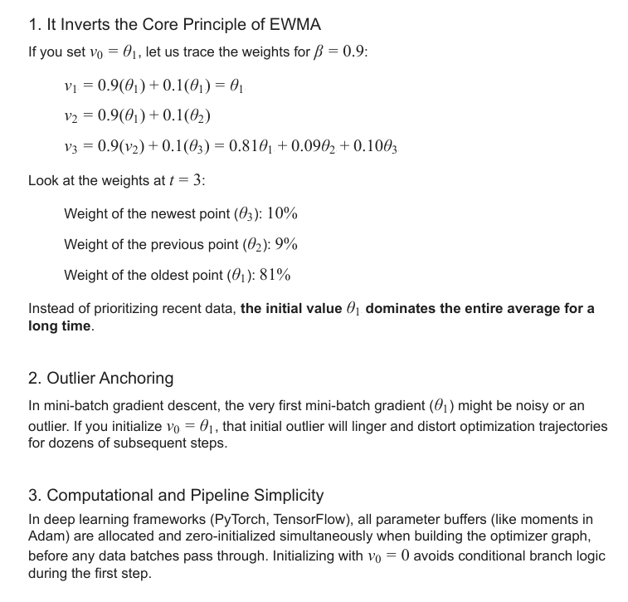

Core Bias Correction
If we sum weights that EWMA has at a given time,
at time t:
V_t has weight (1- β)
V_(t-1) has weight β(1- β) and so on
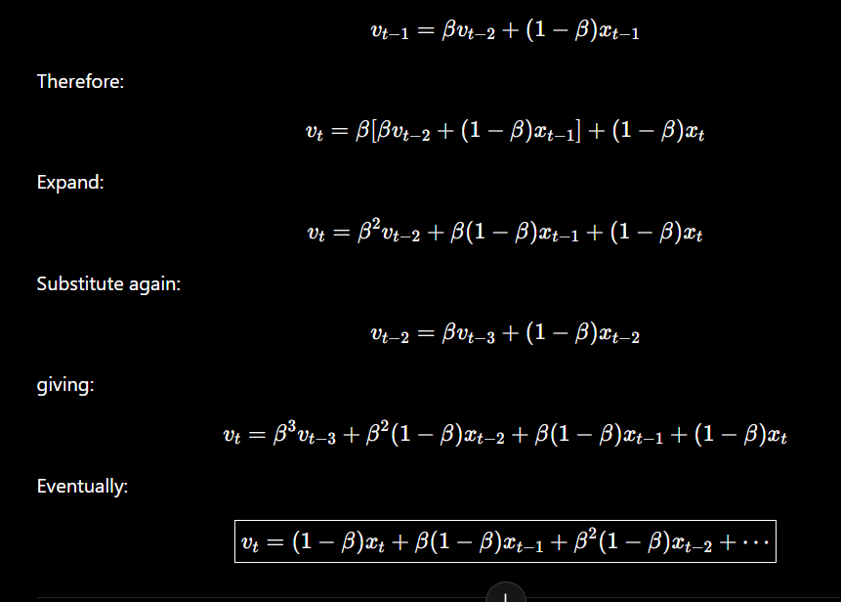
It’s showing V_t got how much weights from previous values.
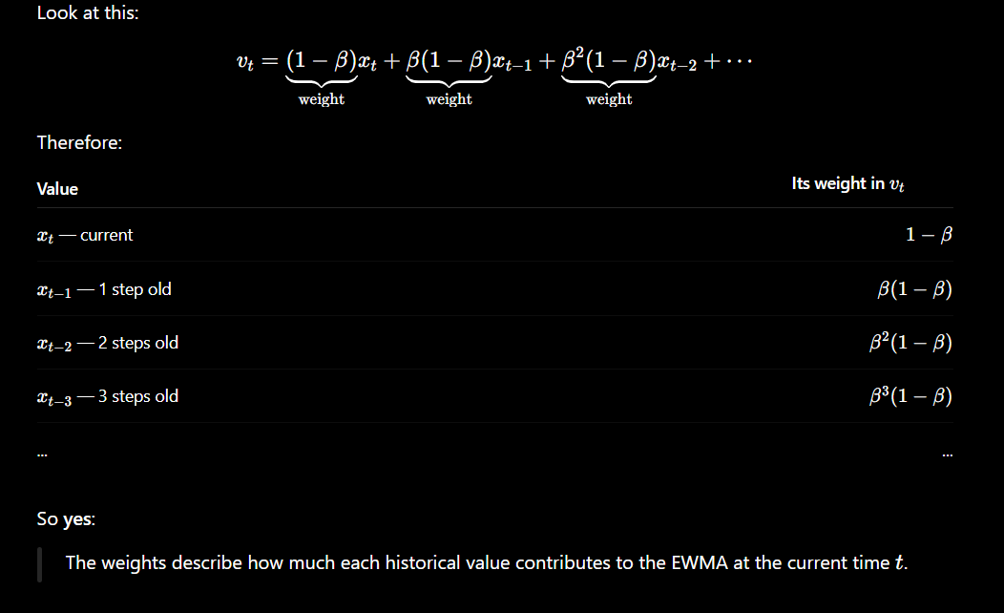
Sum of weights:
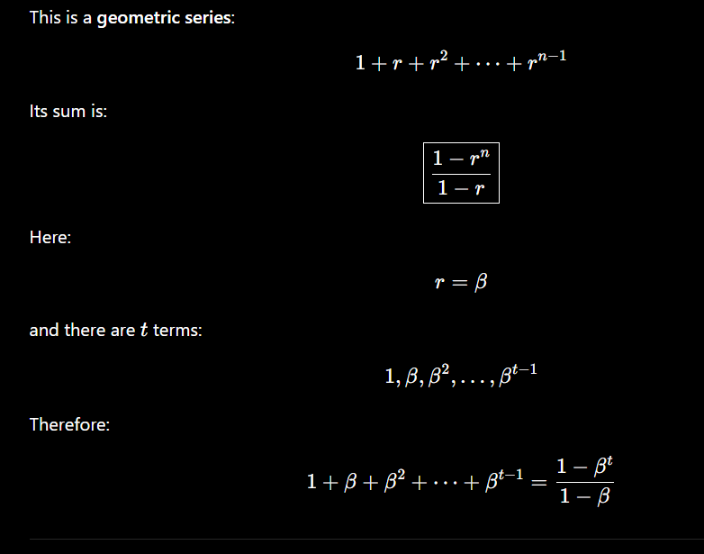
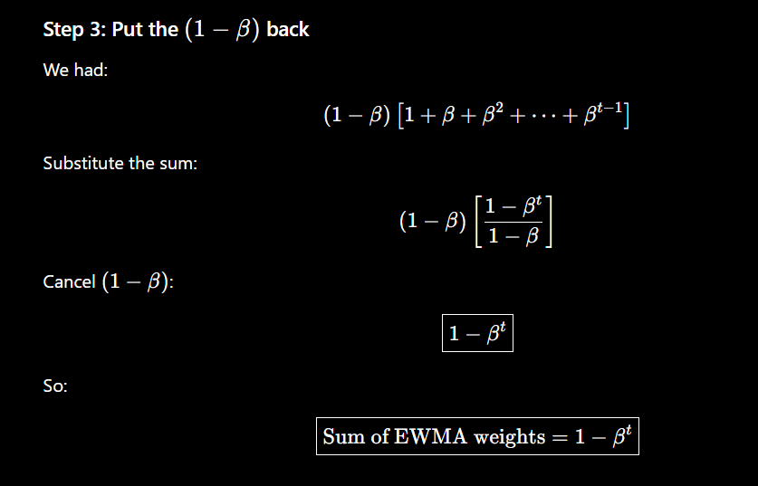
So,
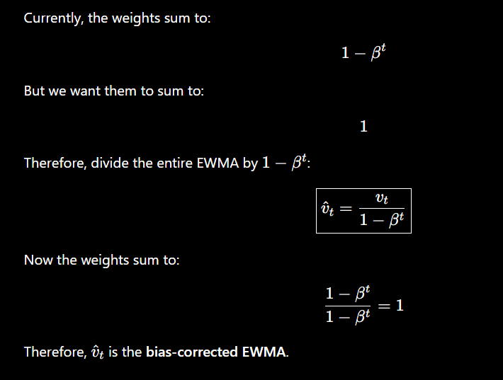
Therefore,
